An Croí
Wisdom Institute

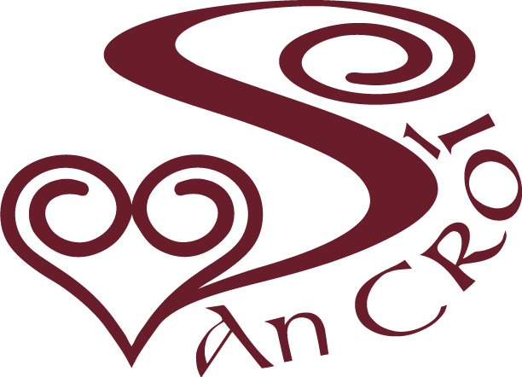
Insert Photo Here

Professional Diploma in
Spiritual Guidance (Direction)
& Soul-Centred Accompaniment
A psycho-spiritual training for spiritual accompaniment
2020-2021
APPLICATION FORM

Name:_________________________

Co- Directors Dr. Geraldine Holton & Ms. Carmel Boyle MMin
An Croí Wisdom Institute & Celtic Spirituality Centre
Main St. Tullyallen, Drogheda, Co. Louth, Ireland Tel. 353 (0)41.9805050
Email : ancroi@eircom.net Website: www.ancroi.ie

Professional Diploma in Spiritual Direction and Soul Guidance
Application Form

Personal Details
Surname

First Name

Mailing Address

Email Address

Date of Birth Telephone (Home) Telephone (mobile)

Present Occupation

Where did you first hear about this programme?

Why would you like to do this programme?

Are you in Spiritual Guidance/Direction?

Educational Background

Title of Award Date Awarded Awarding Institution

Personal information

Experiential Learning

The training programme involves a blend of online learning and experiential learning.

Do you have any experience of online learning? Yes No

Do you able to access internet broadband? Yes No

TWO REFEREES

1. Name

Address

Telephone

Fax

Email

Reason for nominating this referee

2. Name

Address

Telephone

Fax

Email

Reason for nominating this referee

References may accompany the application form
or can be forwarded separately at a later date

Acceptance on the programme is dependent on receipt of references

In aim of this section is provide candidates with an opportunity to offer any personal information that may be important regarding health or otherwise.
The aim of this section is to identify experiential learning which has happened outside formal courses of study. This would include employment, ministry, retreats, seminars or reading which may be relevant to the area of spiritual guidance

